**Statistical Data Distribution**

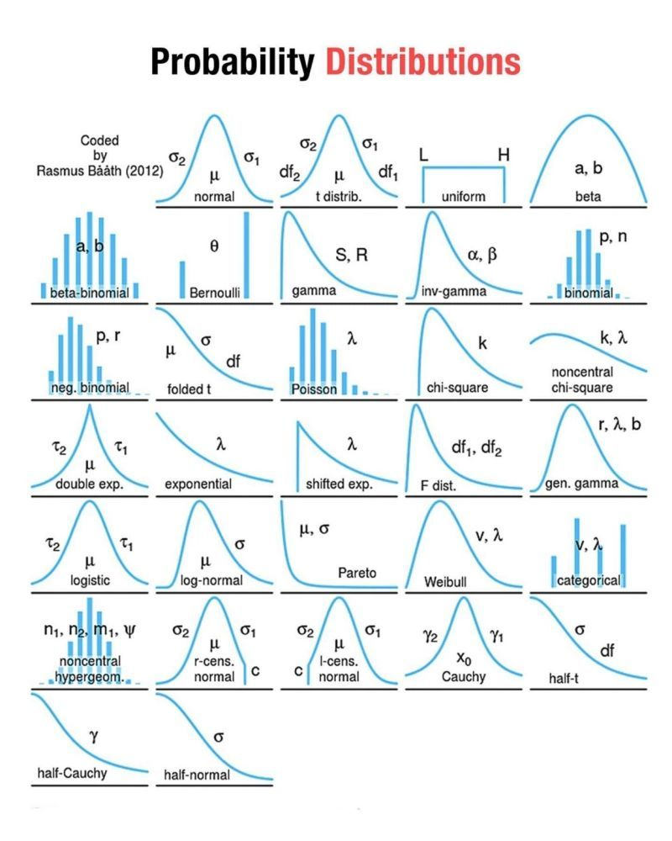

**Normal Distribution:**

The normal distribution, also known as the Gaussian distribution, is the most important probability distribution in statistics for independent, random variables. Most people recognize its familiar bell-shaped curve in statistical reports.

The normal distribution is a continuous probability distribution that is symmetrical around its mean, most of the observations cluster around the central peak, and the probabilities for values further away from the mean taper off equally in both directions. Extreme values in both tails of the distribution are similarly unlikely. **While the normal distribution is symmetrical, not all symmetrical distributions are normal. For example, the Student’s t, Cauchy, and logistic distributions are symmetric**.

**The Empirical Rule for the Normal Distribution**

When you have normally distributed data, the standard deviation becomes particularly valuable. You can use it to determine the proportion of the values that fall within a specified number of standard deviations from the mean. For example, in a normal distribution, 68% of the observations fall within +/- 1 standard deviation from the mean. This property is part of the Empirical Rule, which describes the percentage of the data that fall within specific numbers of standard deviations from the mean for bell-shaped curves.

|  |  |
| --- | --- |
| Mean +/- standard deviations | Percentage of data contained |
| 1 | 68% |
| 2 | 95% |
| 3 | 99.7% |

